Project Design Phase-I
Solution Architecture

Date | 27 October 2026
Team ID | Not provided by user
Project Name | Global Olympic Sports Performance Analysis
Maximum Marks | 4 Marks

Solution Architecture:
Solution architecture is a complex process – with many sub-processes – that bridges the gap between business problems and technology solutions. Its goals are to:
- Find the best tech solution to solve existing business problems.
- Describe the structure, characteristics, behavior, and other aspects of the software to project stakeholders.
- Define features, development phases, and solution requirements.
- Provide specifications according to which the solution is defined, managed, and delivered.

Proposed Solution Architecture Diagram:
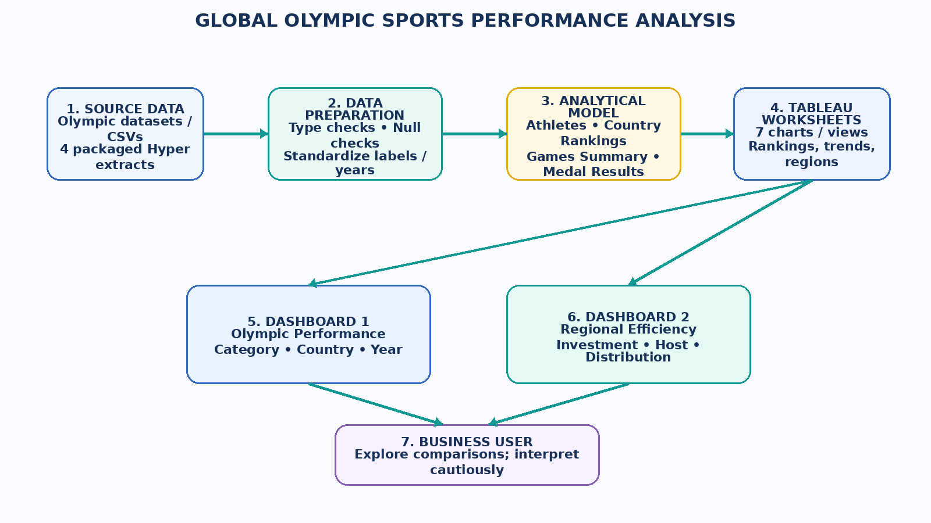

Component Description Table
Component | Technology / Input | Responsibility | Output
Source layer | Four packaged Hyper extracts | Provide athlete, country-rank, games-summary and medal-result attributes. | Consistent analytical inputs
Validation layer | Tableau metadata review; optional SQL/Python checks | Verify data types, nulls, duplicate keys and metric definitions before interpretation. | Quality checklist / issues log
Analysis layer | Tableau worksheets and aggregations | Calculate or aggregate total medals, average medals by category, year totals and regional measures. | Seven visualizations
Presentation layer | Two Tableau dashboards | Organize overall performance and regional efficiency/host views. | Interactive dashboard tabs
Evidence layer | TWBX, screenshots, report and narration | Package reproducible artifacts and explain insights/limitations. | Review-ready submission
Component Name | Description / Role in Architecture | Technology Used
Source Data | Provides athlete, country-ranking, games-summary and medal-result records. | Packaged Tableau Hyper extracts
Analysis Workbook | Contains seven worksheets and two dashboards for descriptive Olympic comparisons. | Tableau packaged workbook (.twbx)
Validation & Reporting | Supports data-quality review, metric caveats, documentation and demonstration. | Tableau, optional Python/SQL checks, DOCX/PDF

Architecture Assumptions and Limitations
The current implementation is a packaged Tableau workbook. The uploaded files do not demonstrate a live Snowflake connection, automated ETL service, Tableau Public publication, or an upstream data-refresh pipeline. These are optional extensions, not claimed as completed components.

